# Q1 to Q12 have only one correct answer. Choose the correct option to answer your question.

1. Which of the following is an application of clustering?
   1. Biological network analysis
   2. Market trend prediction
   3. Topic modeling
   4. All of the above
2. On which data type, we cannot perform cluster analysis?
   1. Time series data
   2. Text data
   3. Multimedia data
   4. None
3. Netflix’s movie recommendation system uses-
   1. Supervised learning
   2. Unsupervised learning
   3. Reinforcement learning and Unsupervised learning
   4. All of the above
4. The final output of Hierarchical clustering is-
   1. The number of cluster centroids
   2. The tree representing how close the data points are to each other
   3. A map defining the similar data points into individual groups
   4. All of the above
5. Which of the step is not required for K-means clustering?
   1. A distance metric
   2. Initial number of clusters
   3. Initial guess as to cluster centroids
   4. None
6. Which is the following is wrong?
   1. k-means clustering is a vector quantization method
   2. k-means clustering tries to group n observations into k clusters
   3. k-nearest neighbour is same as k-means
   4. None
7. Which of the following metrics, do we have for finding dissimilarity between two clusters in hierarchical clustering?
8. Single-link
9. Complete-link
10. Average-link Options:

a. 1 and 2

1. 1 and 3
2. 2 and 3
3. 1, 2 and 3
4. Which of the following are true?
5. Clustering analysis is negatively affected by multicollinearity of features
6. Clustering analysis is negatively affected by heteroscedasticity Options:
   1. 1 only
   2. 2 only
   3. 1 and 2
   4. None of them
7. 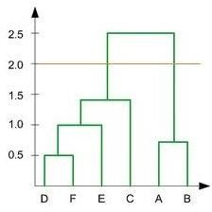In the figure above, if you draw a horizontal line on y-axis for y=2. What will be the number of clusters formed?
   1. 2
   2. 4
   3. 3
   4. 5
8. For which of the following tasks might clustering be a suitable approach?
   1. Given sales data from a large number of products in a supermarket, estimate future sales for each of these products.
   2. Given a database of information about your users, automatically group them into different market segments.
   3. Predicting whether stock price of a company will increase tomorrow.
   4. Given historical weather records, predict if tomorrow's weather will be sunny or rainy.
9. Given, six points with the following attributes:

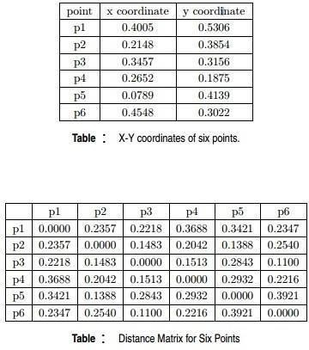

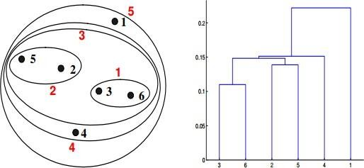Which of the following clustering representations and dendrogram depicts the use of MIN or Single link proximity function in hierarchical clustering:

a.

b. 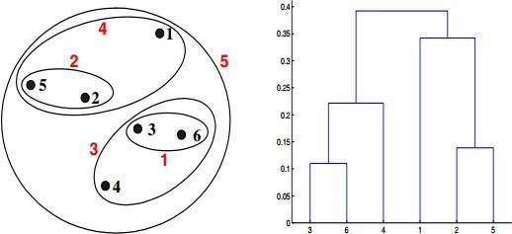

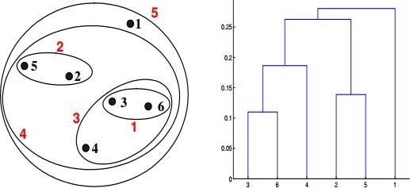

c.

d. 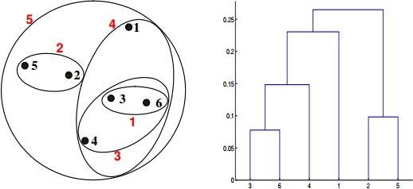

1. Given, six points with the following attributes:



Which of the following clustering representations and dendrogram depicts the use of MAX or Complete link proximity function in hierarchical clustering.

a.

b. 

c.

d.

# Q13 to Q14 are subjective answers type questions, Answers them in their own words briefly

1. What is the importance of clustering?

Clustering is very much important as it determines the intrinsic grouping among the unlabeled data present. There are no criteria for a good clustering. It depends on the user, what is the criteria they may use which satisfy their need.

Clustering and classification allows you to take a sweeping glance of your data en masse, and then form some logical structures based on what you find there before going deeper into the nuts-and-bolts analysis.

Applications of Clustering in different fields

1. Marketing: It can be used to characterize & discover customer segments for marketing purposes.
2. Biology: It can be used for classification among different species of plants and animals.
3. Libraries: It is used in clustering different books on the basis of topics and information.
4. Insurance: It is used to acknowledge the customers, their policies and identifying the frauds.
5. City Planning: It is used to make groups of houses and to study their values based on their geographical locations and other factors present.  
   Earthquake studies: By learning the earthquake-affected areas we can determine the dangerous zones.
6. How can I improve my clustering performance?

As a preprocessing stage of data mining and machine learning, dimension reduction not only decreases computational complexity, but also significantly improves the accuracy of the learned models from large data sets. PCA [11] is a classical multivariate data analysis method that is useful in linear feature extraction. Without class labels it can compress the most information in the original data space into a few new features, i.e., principal components. Handling high dimensional data using clustering techniques obviously a difficult task in terms of higher number of variables involved. The main objective of applying PCA on original data before clustering is to obtain accurate results so that the researchers can do analysis in better way. Secondly, minimize the running time of a system because time taken to process the data is a significant one. Normally it takes more time when the number of attributes of a data set is large and sometimes this dataset not supported by all the clustering techniques hence the number of attributes are directly proportional to processing time.